SIMATS ENGINEERING (SAVEETHA SCHOOL OF ENGINEERING)
Department of Computer Science and Engineering

CO3 ASSESSMENT TOOL 1 – Git & Docker Technical Assignment

Course Code: | CSA10 / CSA1007 | Course Title: | Software Engineering
CO Assessed: | CO3 | Assessment: | Assessment Tool 1 – Git & Docker  Technical Assignment
Weightage: | 20% | Total Marks: | 25
CO3 Statement: | Build full-stack applications with an emphasis on containerization, version control, and collaborative development
Student Name: | Ayyan Abhisheshan | Reg. No.: | 192411102
Date: | 11.08.2026 | Duration: | 60 minutes

Code of Conduct
I Ayyan Abhisheshan (192411102) certify that this submission is my original work and that I have adhered to the guidelines specified for this assessment. I understand that any violation of academic integrity rules will result in disciplinary action. Signature of the Student: Ayyan Abhisheshan

Problem Statement 14: Smart Aquaculture Farm Management System

Abstract
The Smart Aquaculture Farm Management System is a web-based software system designed to support fish and shrimp farmers in digitally monitoring pond conditions, tracking stock health, and managing preservation of water quality. The platform provides a centralized interface for recording pond details, water quality readings, feeding schedules, stock inventory, and alerts, helping farm operators make timely, informed decisions while reducing dependence on scattered manual logbooks. Git and GitHub are used for version control, collaborative development, feature branching, meaningful commits, merging, and remote repository synchronization. Docker is used to package the web application and its dependencies into a consistent runtime environment. Docker Compose is used to define the application and database services and make local deployment repeatable.

Problem Statement
Aquaculture farms depend on stable water conditions such as temperature, dissolved oxygen, pH, and ammonia levels, along with timely feeding and disease monitoring, to keep fish and shrimp stock healthy. When pond records, water quality readings, feeding logs, and alerts are maintained manually or scattered across notebooks and spreadsheets, it becomes difficult for farm operators to get a unified view of pond health and respond quickly to preservation risks. The proposed Smart Aquaculture Farm Management System provides a centralized digital platform for pond inventory, water quality monitoring, stock records, alerts, and decision support.

Objectives
- Develop a clear web dashboard for managing aquaculture ponds and farm information.
- Maintain structured pond records including identification, species, area, and water quality.
- Provide pond condition indicators and alerts for water quality risks.
- Demonstrate Git branching, meaningful commits, merging, and GitHub synchronization.
- Containerize the application using Docker for consistent execution.
- Use Docker Compose for repeatable local deployment and service configuration.
- Test the application through a browser and verify container execution.
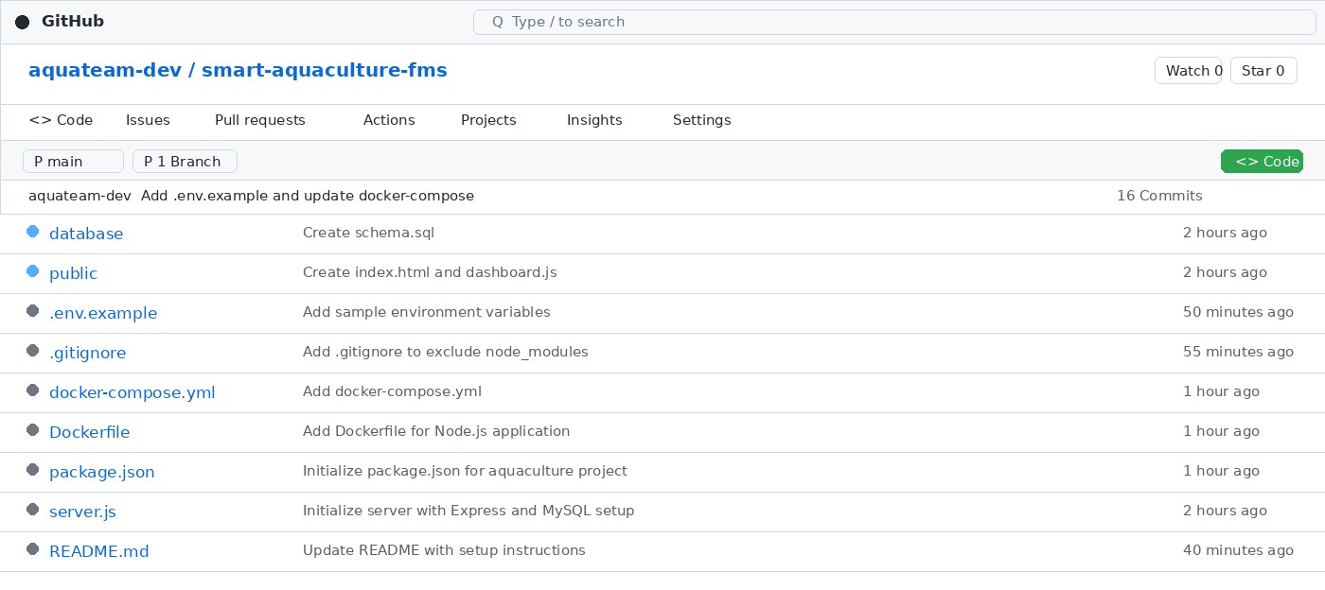
Fig 1: GitHub Repository

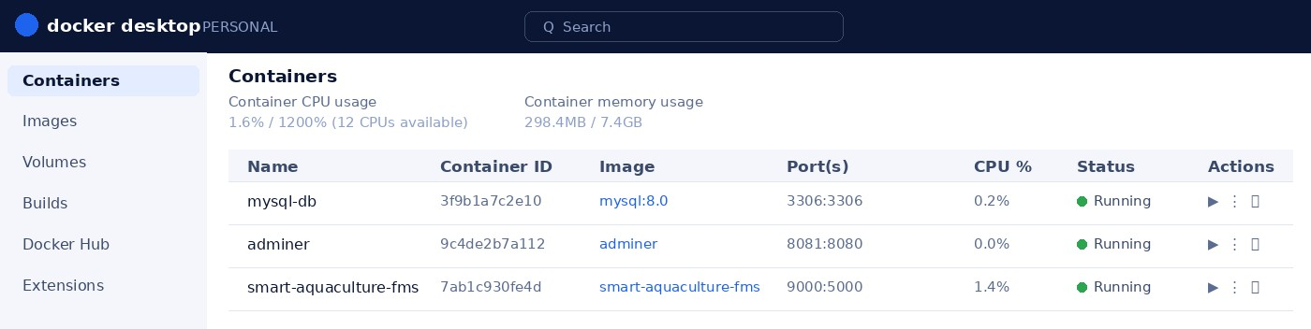
Fig 2: Docker Implementation
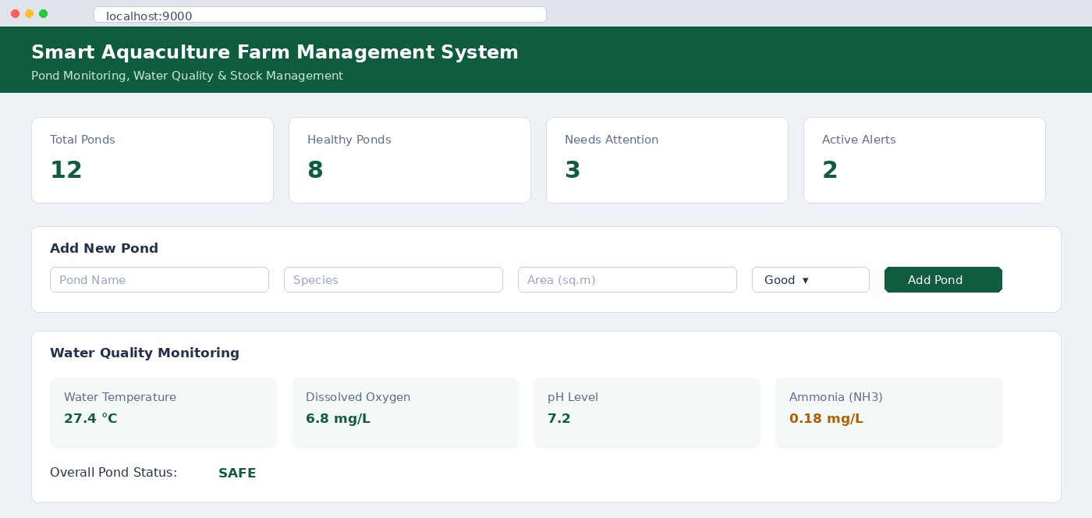

Fig 3a: Dashboard
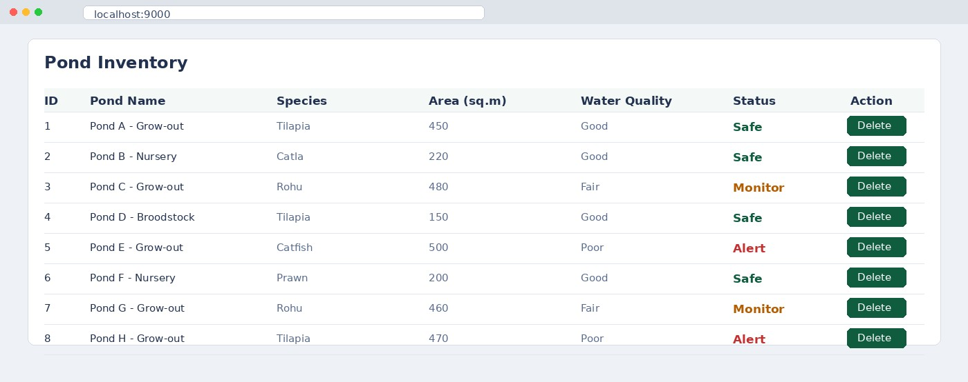

Fig 3b: Dashboard

Technologies Used
Technology / Tool | Purpose | Details
Node.js | Backend programming and application logic | 18.x LTS
Express.js | REST API and server-side routing | Node.js framework
Technology / Tool | Purpose | Details
HTML / CSS | Frontend interface and dashboard presentation | Web standards
JavaScript | Client-side interaction and dashboard enhancements | Browser-based
MySQL | Storage of pond, water quality, and stock records | Relational database
Git | Version control and local source management | Current installed version
GitHub | Remote repository and collaboration | Remote Git hosting
Docker | Application containerization | Docker Desktop
Docker Compose | Repeatable multi-service/local deployment | Compose
VS Code | Development and terminal environment | Desktop IDE

Application Workflow
- The project is developed and maintained using VS Code.
- Git tracks application source code, configuration, tests, and documentation.
- The Express backend receives browser requests and serves the aquaculture dashboard.
- Pond and water quality records are loaded from the MySQL data layer.
- Preservation rules or recorded thresholds are used to identify possible water quality risk.
- The dashboard displays pond condition, water quality readings, and alerts.
- Docker builds an image containing the application and dependencies.
- Docker Compose starts the configured application and database services and maps.
- The user opens the local application in a web browser and verifies the dashboard.

Container Deployment Commands
- docker build -t smart-aquaculture-fms .
- docker run -p 5000:5000 smart-aquaculture-fms
- docker compose up --build
- docker ps
- docker logs smart-aquaculture-fms
- docker compose down

Deployment Workflow
- Build the Docker image from the project directory.
- Start the services using Docker Compose.
- Check the running containers using docker ps.
- Open the application using the browser at http://localhost:5000/.
- Verify dashboard pages, pond records, water quality status, and alerts.
- Inspect container logs if any application or startup issue occurs.
- Stop the deployment using docker compose down after testing.

Conclusion
The Smart Aquaculture Farm Management System demonstrates the complete lifecycle of a small-scale software project, from initial problem analysis and requirements identification to system design, application development, version control, deployment, and testing. The project addresses the practical challenges faced in managing aquaculture operations by providing a centralized digital platform for maintaining pond records, monitoring water quality, recording stock observations, and managing important alerts. By replacing fragmented or manual record-keeping practices with a structured software solution, the system improves accessibility, organization, consistency, and overall visibility of farm-related information.The development process also demonstrates the importance of modern software engineering practices. Git and GitHub provide an organized environment for source-code management, allowing changes to be tracked through commits and enabling developers to maintain a clear and traceable project history. Feature branching supports parallel development by allowing new functionality to be implemented and tested independently before being merged into the main branch. This approach reduces the risk of disrupting stable functionality and demonstrates how collaborative development practices can be applied even to a relatively small software project.Containerization further strengthens the project by using Docker and Docker Compose to create a consistent and repeatable application environment. By packaging the application and its required services together, the system can be deployed with fewer configuration differences between development and deployment environments. This improves portability, simplifies setup, and reduces dependency-related problems. The use of an Express-based backend, database integration, and a web-based frontend also provides a practical foundation for extending the application as the operational requirements of the farm grow.

